Gazi university DG Khan
Name:maheen Fatima
Roll no :13
Bs Computer science
(1st semester)
Submitted to : Mr Asad Majeed
Section D
Lab number 03
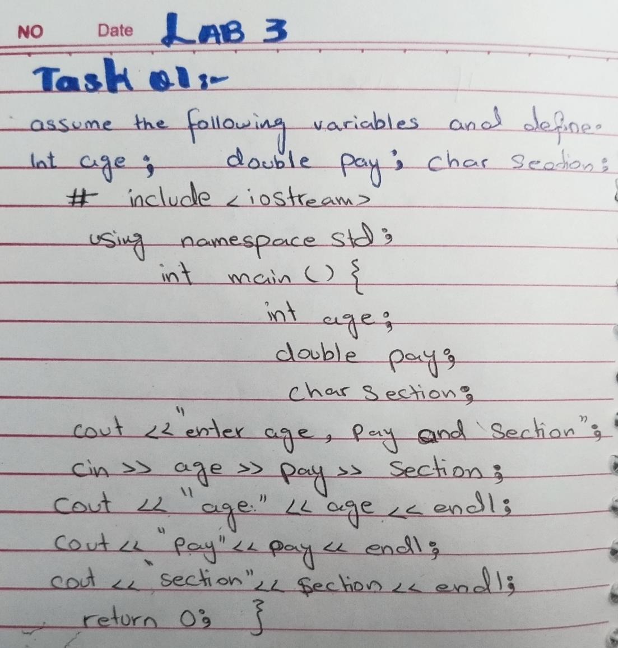
Task no 01
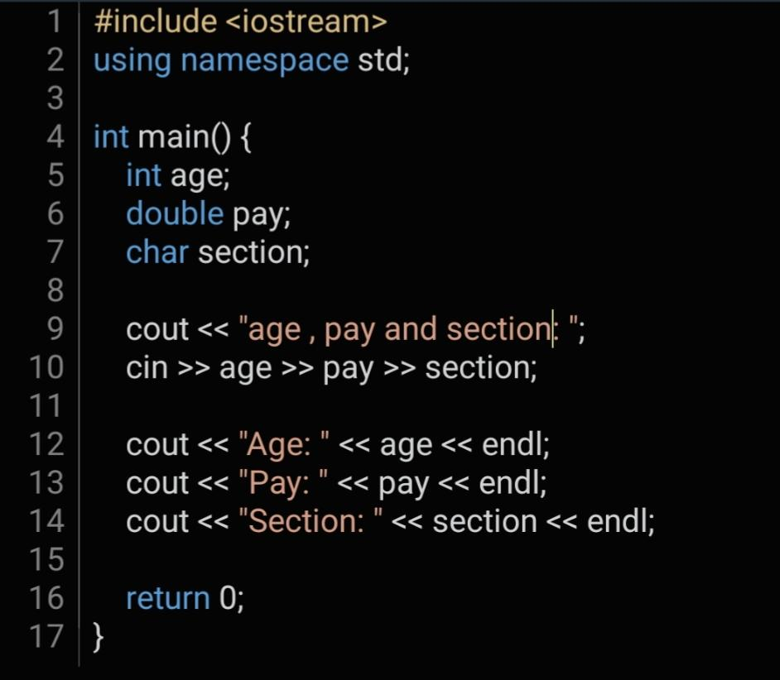

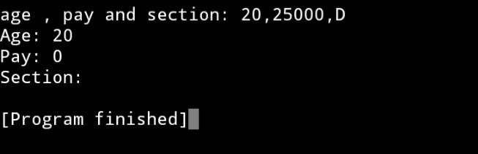
Output...

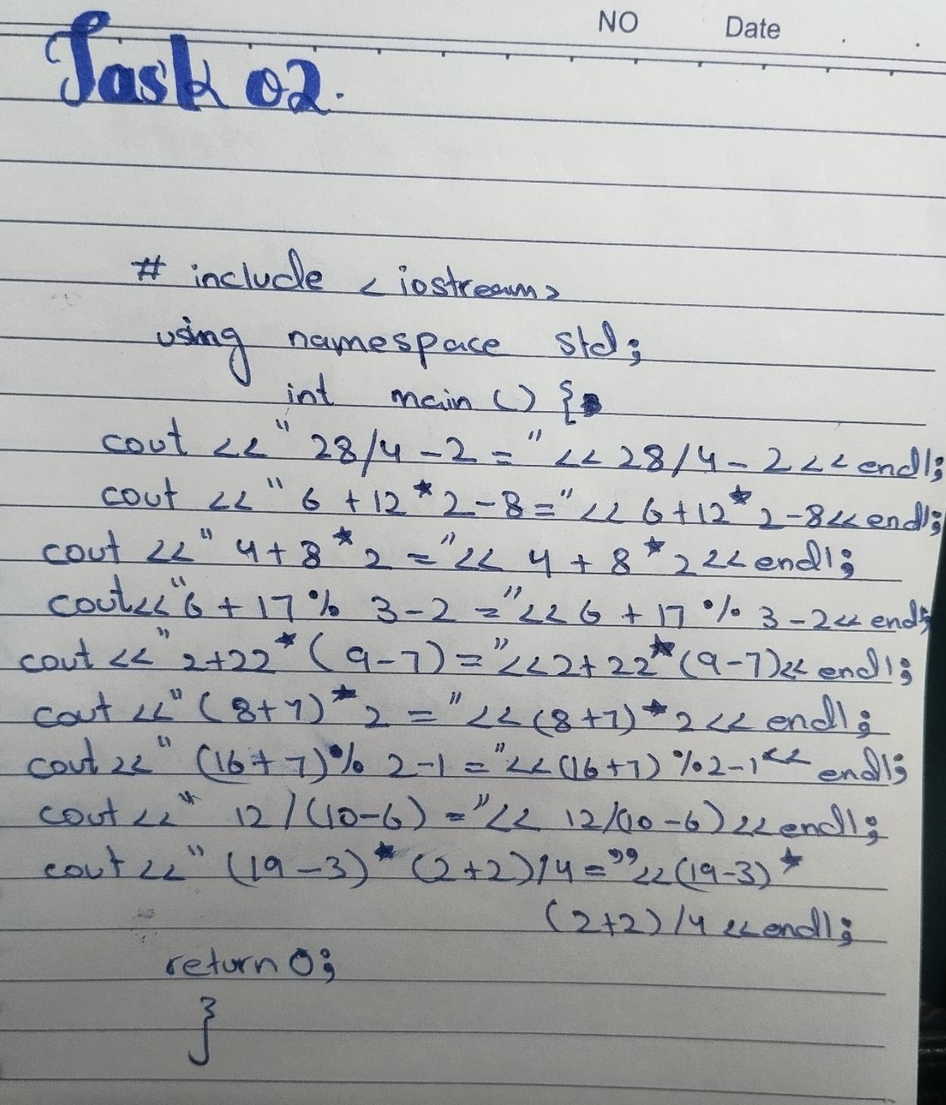
Task number 02.
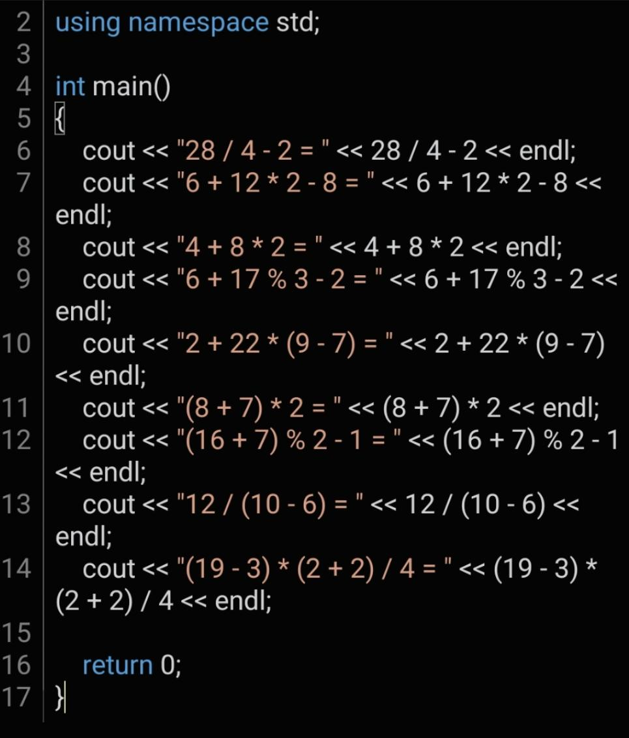
Output...
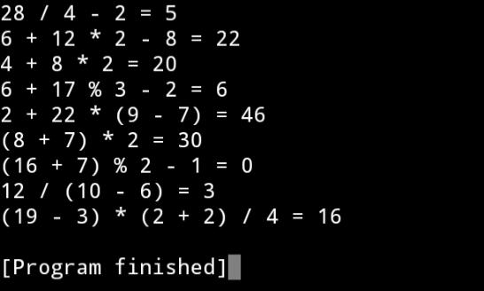

Task 03.
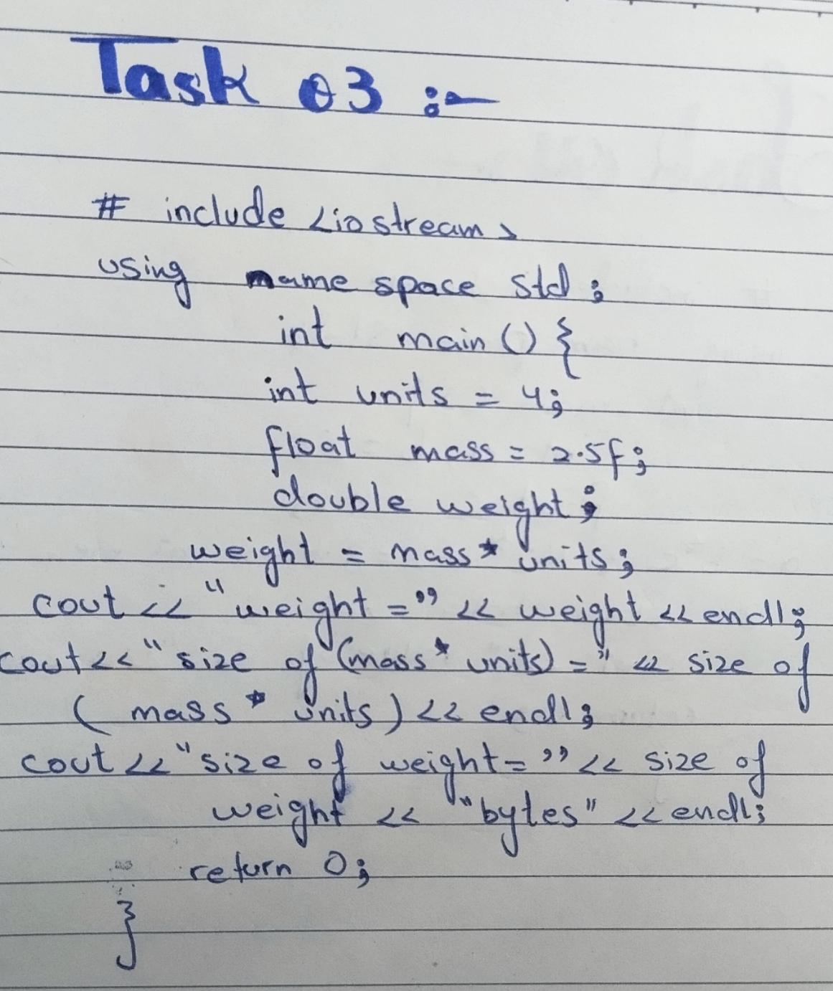
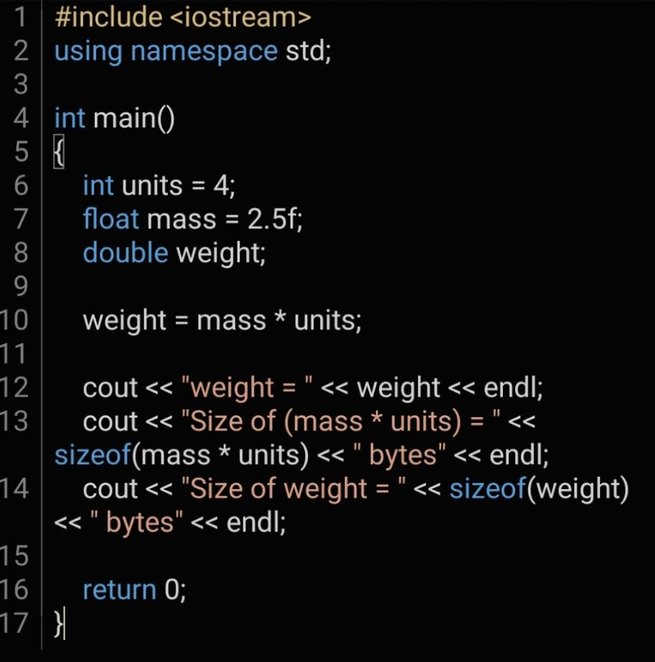
Out put...
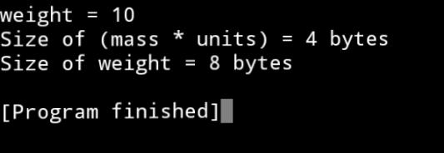
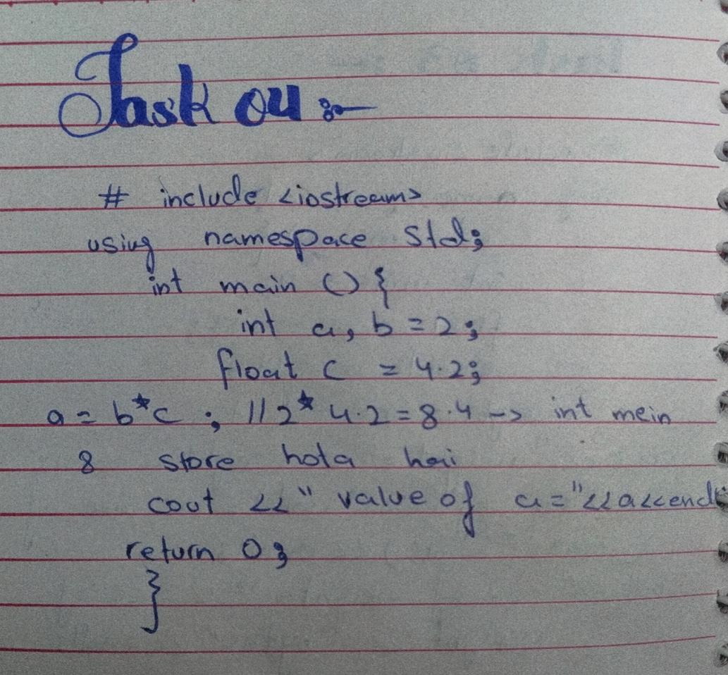
Task 04.
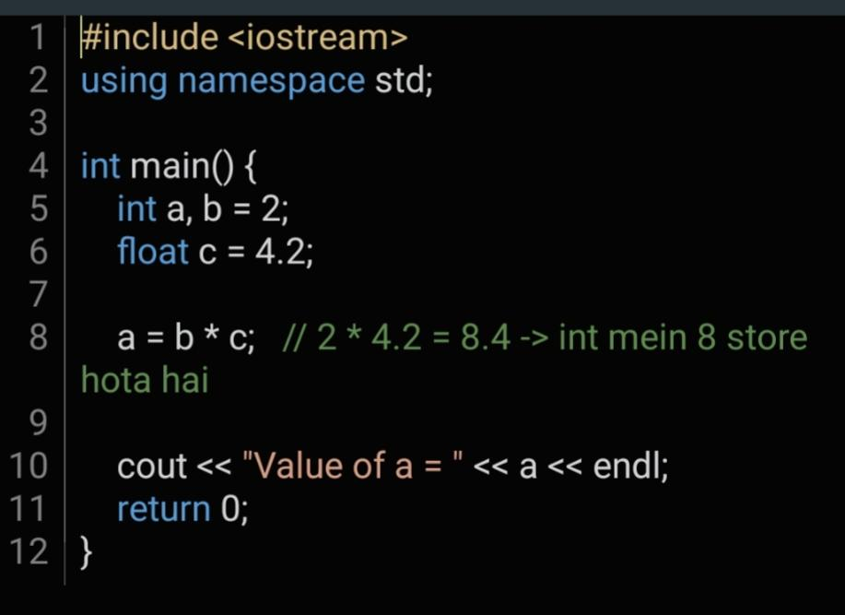
Out put...
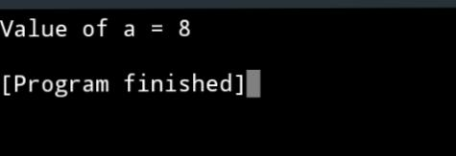

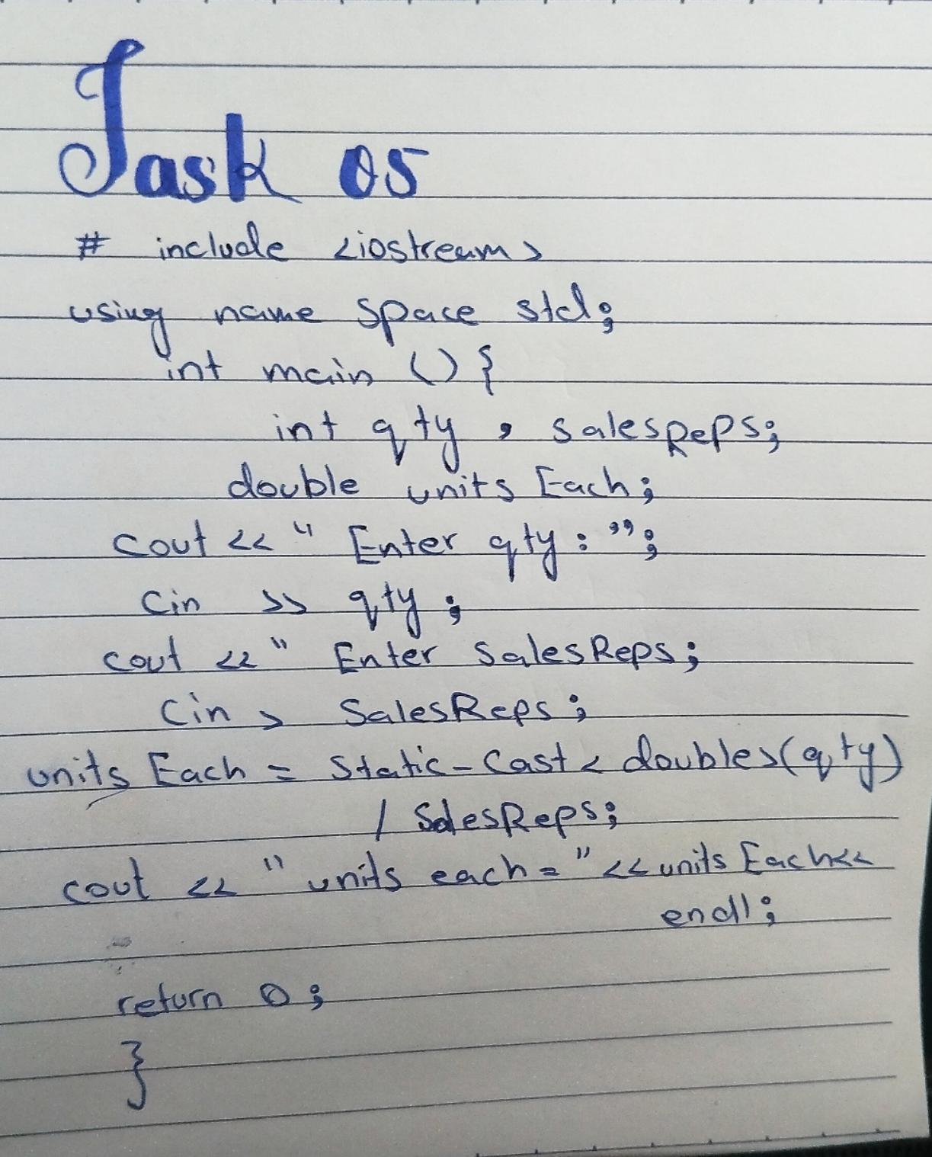
Task05

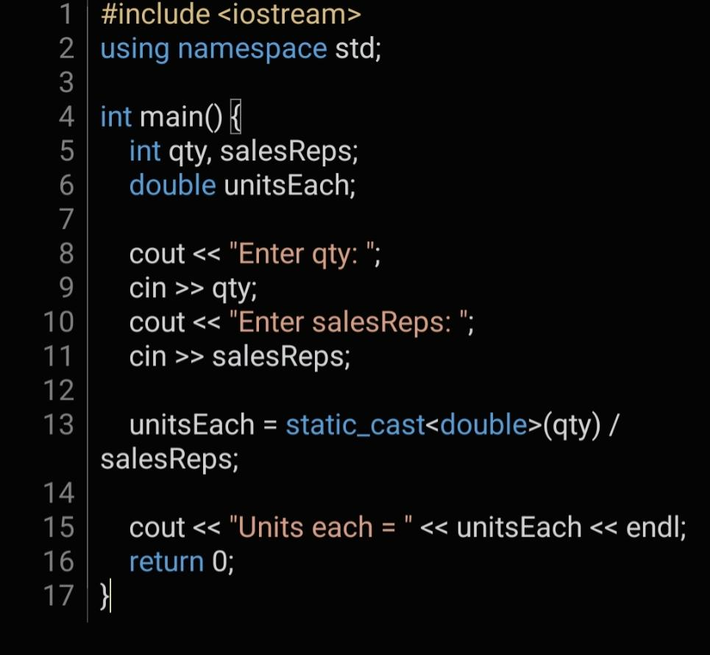

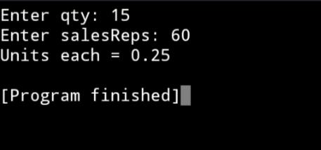
Out put....

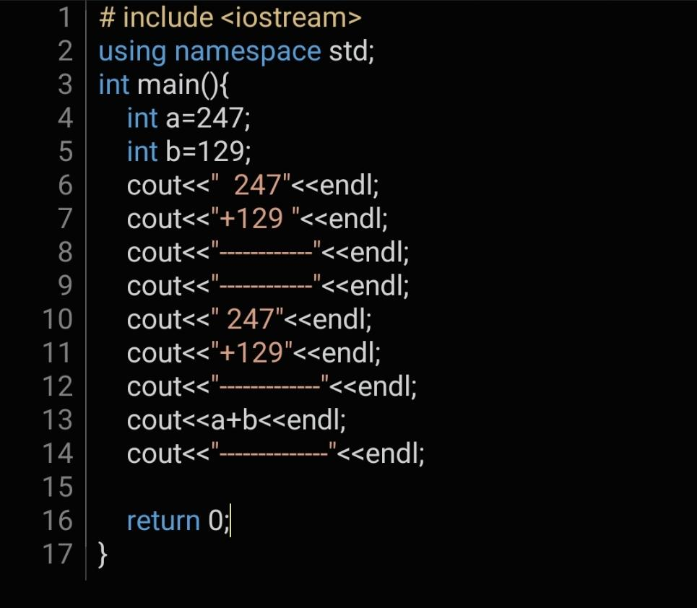
Task 06
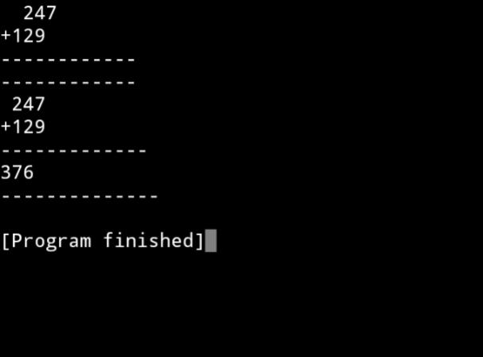
Output....
Home task
Task 01
Each of the following programs has some errors. Locate as many asyou can
.Program-1
errors:1.
The line #include <iostream> is missing.
2. void main() should be int main().
3. Cin should be cin (C++ is case sensitive), and the operator should be >> not << for input.
4. cin << number2; must be cin >> number2;
5. number1 + number2 = sum; must be sum = number1 + number2;
6. The last cout is missing << after cout and has no semicolon at the end.
Corrected Program-1:
#include<iostream>
using namespace std;
int main(){
double number1, number2, sum;
cout << "Enter a number: ";
cin >> number1;
cout << "Enter another number: ";
cin >> number2;
sum = number1 + number2;
cout << "The sum of the two numbers is " << sum;
return 0;}
Output:
Enter a number: 14.5
Enter another number: 20.25
The sum of the two numbers is 34.75
Process exited after 2.3 seconds with return value 0Press any key to continue
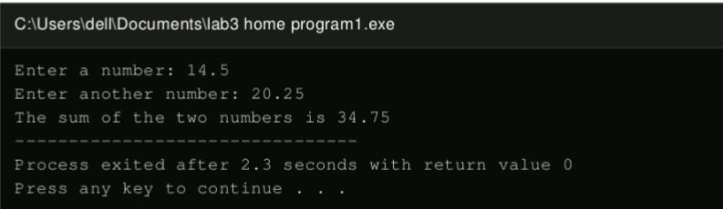
Program-2 errors:
1. void main() should be int main().
2. float<static_cast>(number1) is written the wrong way round; it should bestatic_cast<float>(number1).
3. The line cout << quotient has no semicolon.
Corrected Program-2:
#include <iostream>
using namespace std;int main(){
int number1, number2;
float quotient;
cout << "Enter two numbers and I will divide\n";
cout << "the first by the second for you.\n";
cin >> number1 >> number2;
quotient = static_cast<float>(number1) / number2;
cout << quotient;
return 0;}
Output:
Enter two numbers and I will divide the first by the second for you.17 44.25
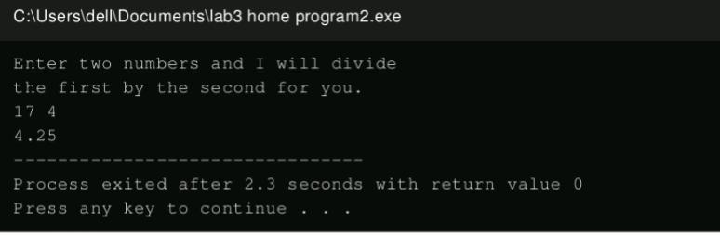
Process exited after 2.3 seconds with return value 0Press any key to continue . . .

Task 02
Average of Values: store the values 36, 41, 29, 38 and 31 in five differentvariables. Calculate their sum in a variable named sum, then divide sum by 5 toget the average and display it.
#include<iostream>
using namespace std;
int main(){
int v1 = 36, v2 = 41, v3 = 29, v4 = 38, v5 = 31;
int sum;
double average;
sum = v1 + v2 + v3 + v4 + v5;
average = sum / 5.0;
cout<<"sum = "<<sum<<endl;
cout<<"average = "<<average<<endl;
return 0;
}
Output
sum = 175
average = 35
Process exited after 2.3 seconds with return
